UCUBE
COMPILED BY
THE DEVILS ADVOCATE

The following is not written in stone and is certainly not exact science so don’t treat it as such
It is an endeavour to improve cube understanding
For middle of the road players like myself
In the early and middle game
Pleasure and serious players alike
Who play BG matches online
Perhaps a good maxim for cube theory is
"If you think you understand it then you probably don't”
Maybe you prefer Woolsey's law
“If you don't understand it do it” (My interpretation)
The need is there for sure
This is certainly not the definitive article
Just the germ of an idea
Maybe that should read gem of an idea lol
To help recognise cube situations
If you analyse your games you will notice
Cube errors are punished big time
Your rating crashes out
Getting it right or wrong can have a huge effect
On the outcome of the match
So you thought you were unlucky
Get the cube right and you will improve your luck
Time for a rant
I never never wish good luck
In my opinion It is hypocritical in the extreme
What's it really mean ?
Maybe it's the good luck I get from their poor play
Maybe it's the good luck I get from my brilliant play
With both checkers and cube
Maybe it's the perceived luck I get from the dice
Maybe it's a panacea in the event that they lose
Maybe it's always just luck
Who knows
Good play creates good luck
Great play creates outrageous good luck
It's a stupid unnecessary protocol

Most people rely on the formula
P R A T = cube decision
Position Race And Threat

For the inexperienced player this can lead to plenty of errors
You will recognise the following formula
E = mc²
Do you recognise the following expansion
E = ( 1 + (v/c)^2 /2 + O((v/c)^4) )mc^2 = mc^2 + mv^2 / 2 + ...........
Is that you at the back of the room raising your hand
If so read no further
We need to expand PRAT
POSITION
You have a four-point prime
You are holding your five-point
Your opponent has a man on the bar
And so on
RACE
Fortunately the pip count is available online
It just needs simple arithmetic to utilise it
THREAT
You may hit a blot
You may make a four-point prime
You may make a home point
And so on

Let's get down to the nitty-gritty
At the start of each game each player
Has a 50% chance of winning
If percent is a rude word just use points
To win you need 100 points
You need to determine how many points
Your position is worth and add it on to your starter 50
Example 50+10=60
Your opponents new value is 100-60 = 40
You are winning but when do you use the cube
If your opponent has less than 25 its normally cube and drop
If you have over 75 it's normally too good
Play on for a gammon etc
Now the grey area when is it a cube and take
Lets say between 68 and 75
A narrow window
Calculate the cube value from the point of view of the cuber
So lets give some points to our positions
Get a recent analysed match showing cube decisions
In which you were robbed of victory by bad luck
Paper and pencil to hand
Your going to use the expanded version of PRAT
When you know your times tables
You can do arithmetic
When you can count your position points
You can do the cube (not rubicks)
Don't get excited
That's not the end of the road
There is the question of match-winning chances MWC
Potential Gammons and backgammons
Effective pip count
That can effect the decision
Forget those for the moment
I will express the opinion later that you should forget match-winning chances
Forget about market as well ,A well overhyped buzz word
Used by some to impress but seldom utilised
Until you get to Vegas
Obviously you will not be allowed your bits and pieces to calculate in play
Time and protocol forbids LOL
If you do the exercise there will be an intrusion of understanding
The time will come when you realise whats important
You will recognise positions in play
A practice used by chess players
If you have XG the stats are staring at you
You can compare your calculations
If you have not got XG you're not a serious player
Or maybe very poor (financially)
These are the parameters I am going to consider and give values to
I am sure they are not comprehensive
You may well be adding your own and dropping others
Race
Primes
Advanced anchor
Runners escaped
Opp on bar
Opp behind prime
Builders and threats
Home points made
Five point made
Crossovers
Gammon chances
Still plenty of play LOL (it has a value)
Whatever else you may fancy
You may even get to create rule of thumb
A good pneumonic would be handy
The following are my suggestions for values
Create or amend for your improvements
These will expand PRAT
In time you will be in a much better position
To pass or accept the cube
Do the exercise do the exercise
You will begin to recognise positions
And be able to give it further knowledgeable thought
Without using paper and pencil

Race
Pip difference divided by seven +1 ( max of 5 points)
This of course can be negative
Runners
1 away 2 points
2 away 5 points
Home points made
1 point for each
Five point made
2 points
Advanced anchor
As per the point
Opponent on bar
Two times points made times number on bar
Opponent behind prime
1 times checkers trapped times number in prime (minimum of three in prime)
Plus a further 1 times checkers for any chequer that requires 2 dice to escape
The one on the bar has to be costed as well
Threat and builders
Your decision, too many situations
Anything between 1 and 6 then Infinity
If your going to make a home point maybe 2
If you're going to trap a chequer behind a six prime then fill your boots
Gammon potential
You decide 0, 2,4,6 it can be the deciding factor
XG don’t appear to include it in their stat figure its treated as a separate item
Miscellaneous Einstein had a constant so we have one
Anything that catches your eye that you may not have covered
Negative or positive points in opponents position and yours etc
Consider outfield control and X overs when necessary
If both parties have the same which can be glaringly obvious no cube
A few examples to clarify
On reflection maybe not an ideal set
Nonetheless I think they prove a point
EXAMPLE A
BROWN TO CUBE

 | A
RACE | 3
RUNNERS | 2
HOME POINTS MADE | 1
5 POINT MADE
ADVANCE ANCHOR
OPP ON BAR
OPP BEHIND PRIME | 12
THREAT & BUILDERS | 2
GAMMON POTENTIAL | 2
MISCELLANEOUS | -2
X OVERS
TOTAL | 70
XG | 69
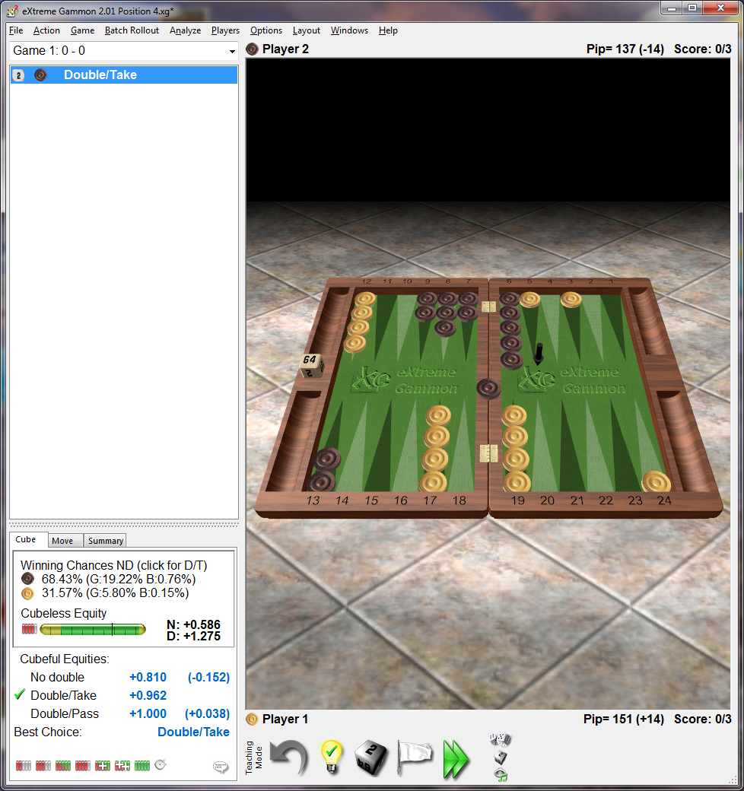

White has nothing at the moment
A 4 point prime can be a challenge especially if i get another chequer back
He may end up with a high anchor so no gammon
Still plenty of play at this score and position
Falls in the D/T range
As per XG Notice runners not away

EXAMPLE B
Brown to cube

 | B
RACE | 1
RUNNERS
HOME POINTS MADE | 4
5 POINT MADE | 2
ADVANCE ANCHOR | 5
OPP ON BAR | 8
OPP BEHIND PRIME | 4
THREAT & BUILDERS
GAMMON POTENTIAL
MISCELLANEOUS | 2
X OVERS
TOTAL | 76
XG | 78

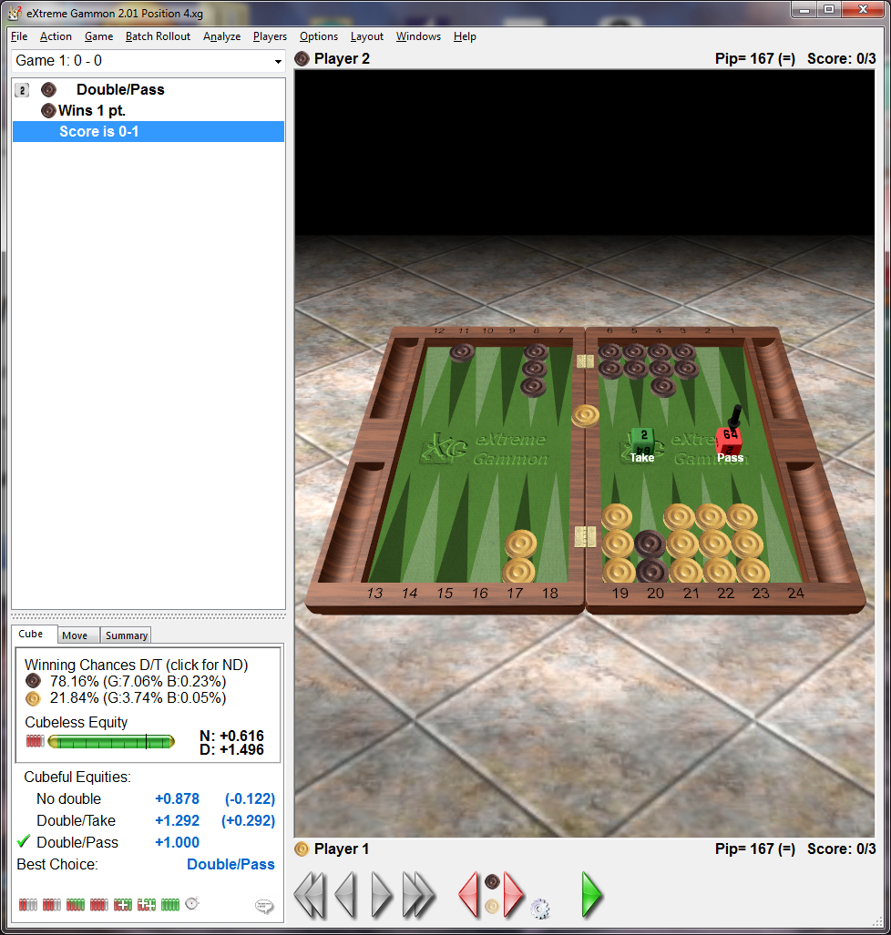
Falls in too good range but is cube/drop, very small gammon chances on account of high anchor
So no point in playing on

EXAMPLE C

White to cube

 | C
RACE
RUNNERS | 2
HOME POINTS MADE | 5
5 POINT MADE | 2
ADVANCE ANCHOR
OPP ON BAR
OPP BEHIND PRIME | 5
THREAT & BUILDERS | 2
GAMMON POTENTIAL
MISCELLANEOUS | -2
X OVERS
TOTAL | 64
XG | 61
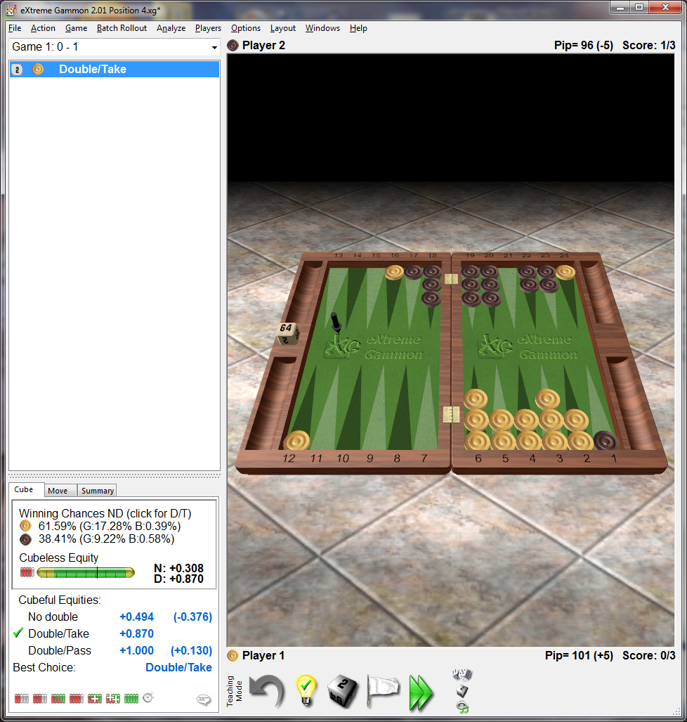

White is winning for sure but the points are adrift of XG figures
Notice both have a runner in prison
time to be cautious
given the chance white is likely to hit loose
what they call a volatile position i beleive
XG double/take yet not what points say must be on account MWC
And the small Gammon chance
I would wait no cube

EXAMPLE D

WHITE TO CUBE

 | D
RACE | 1
RUNNERS
HOME POINTS MADE | 3
5 POINT MADE
ADVANCE ANCHOR | 5
OPP ON BAR
OPP BEHIND PRIME | 6
THREAT & BUILDERS
GAMMON POTENTIAL | 2
MISCELLANEOUS
X OVERS
TOTAL | 67
XG | 62
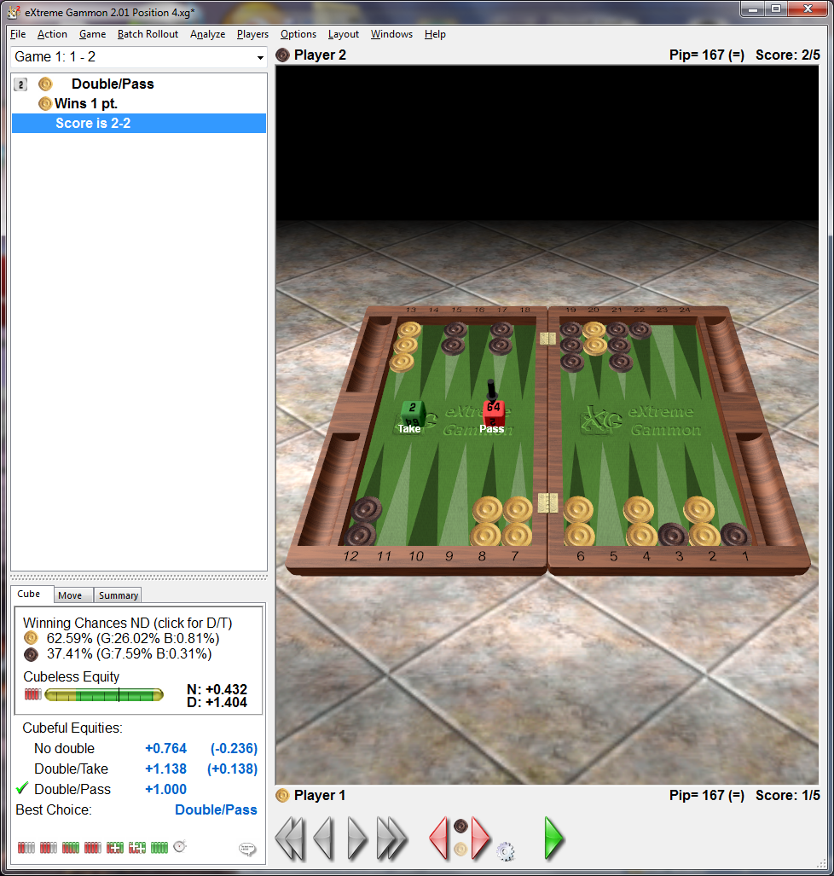

Im too generous maybe the chance for brown too anchor or run with a checker
Still it D/P as per XG
The gammon chances are good
Both parties have to be thinking gammon and MWC at every cube
You don’t have to be brain of Britain to notice that white has gammon chances
At this match score a wise drop
On account of gammon chances
I have a suspicion that xg don’t include gammon chances in their stat

EXAMPLE E

White to cube

 | E
RACE | 5
RUNNERS | 5
HOME POINTS MADE | 3
5 POINT MADE
ADVANCE ANCHOR
OPP ON BAR
OPP BEHIND PRIME | 6
THREAT & BUILDERS
GAMMON POTENTIAL
MISCELLANEOUS
X OVERS | 2
TOTAL | 71
XG | 76
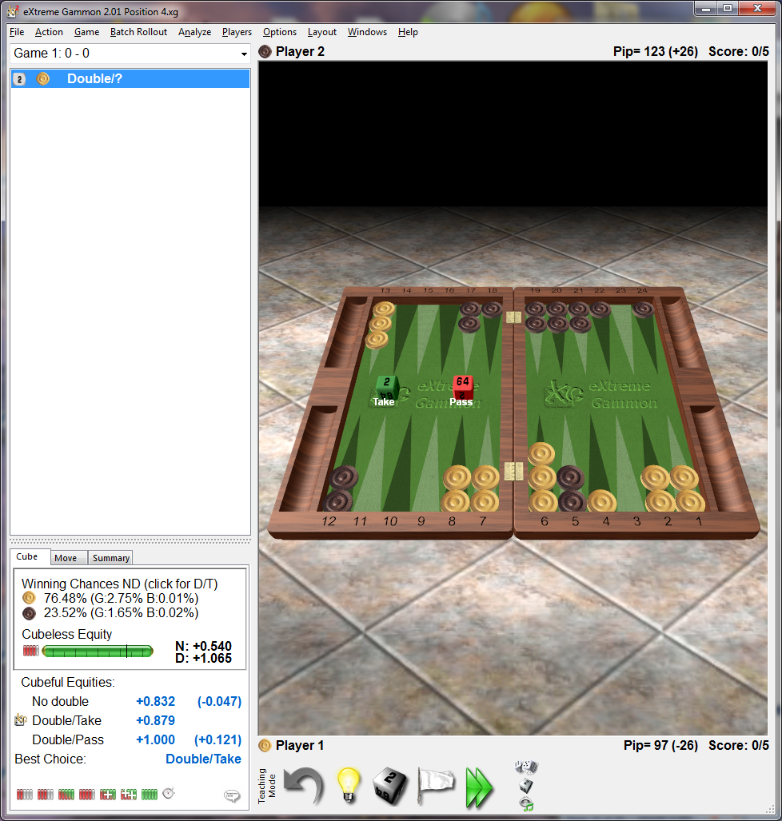

Points in agreement
with blacks high anchor certainly not too good
Although XG gives D/T in a short match i would lean to D/D

EXAMPLE F
BROWN TO CUBE
In play was D/T
 | F
RACE | -1
RUNNERS | -5
HOME POINTS MADE | 2
5 POINT MADE | 2
ADVANCE ANCHOR
OPP ON BAR
OPP BEHIND PRIME | 12
THREAT & BUILDERS | 2
GAMMON POTENTIAL
MISCELLANEOUS
TOTAL | 62
XG | 60
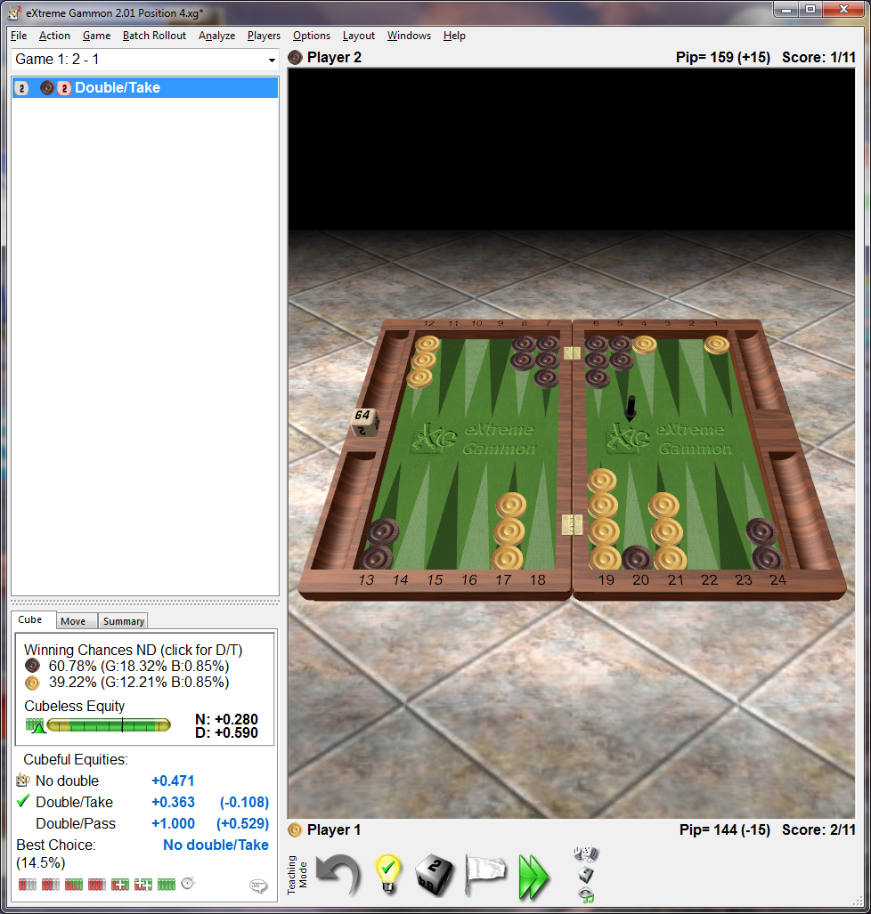

MISCELLANEOUS- BROWN STILL GOT 3 RUNNERS PLUS HE WOULD LIKE TO DO SOMETHING BOTH SIDES OF BOARD
ACTUAL PLAY CUBED IN HASTE DROPPED WITH ALACRITY
A SLAM DUNG AS YOU WOULD SAY OVER THERE
NO IT AINT I SAY, I HAVE A SECRET,
IF RUNNERS NOT AWAY BE AFRAID BE VERY AFRAID
I CAN SEE IT STRAIGHT AWAY
SO CAN YOU NOW
A GOLDEN RULE OF THUMB
IF RUNNERS NOT AWAY BE SHY AND RETIRING
ALWAYS WARRANTS CLOSE STUDY, NEVER ACT IN HASTE IN SUCH POSITIONS
SOME MAY RECOGNISE THIS GAME A CLASSIC EXAMPLE OF CUBE ERROR
BY BOTH PARTIES

EXAMPLE G
 | G
RACE | 3
RUNNERS | 5
HOME POINTS MADE | 1
5 POINT MADE
ADVANCE ANCHOR
OPP ON BAR
OPP BEHIND PRIME
THREAT & BUILDERS | 4
GAMMON POTENTIAL
MISCELLANEOUS
TOTAL | 63
XG | 65
Brown to cube

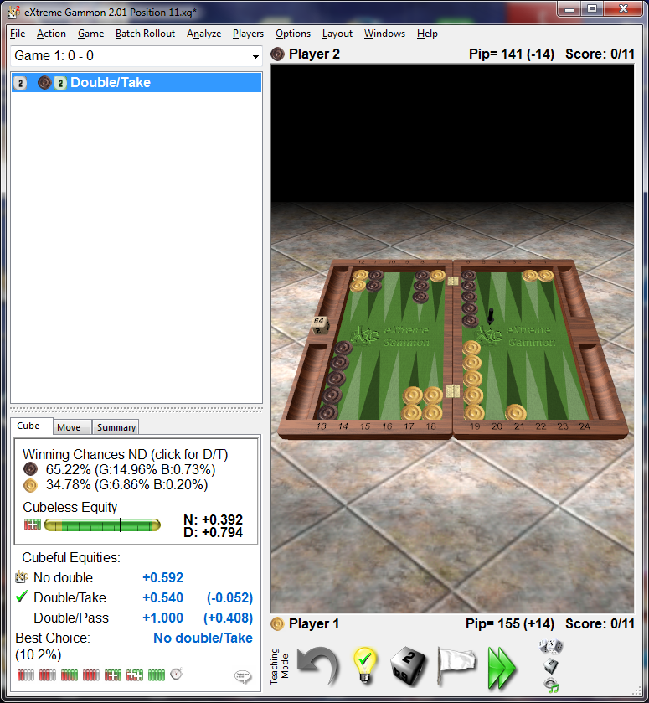
In actual play was D/T
Just looking at it tells you brown is well short of something
May be a student of PRAT felt confident about it
Race and threat for sure , position certainly not
In actual play brown lost
No cube as per stats

EXAMPLE H
 | H
RACE | 1
RUNNERS
HOME POINTS MADE | 4
5 POINT MADE | 2
ADVANCE ANCHOR
OPP ON BAR
OPP BEHIND PRIME | 20
THREAT & BUILDERS | 2
GAMMON POTENTIAL
MISCELLANEOUS | -2
TOTAL | 77
XG | 75
White to CUBE

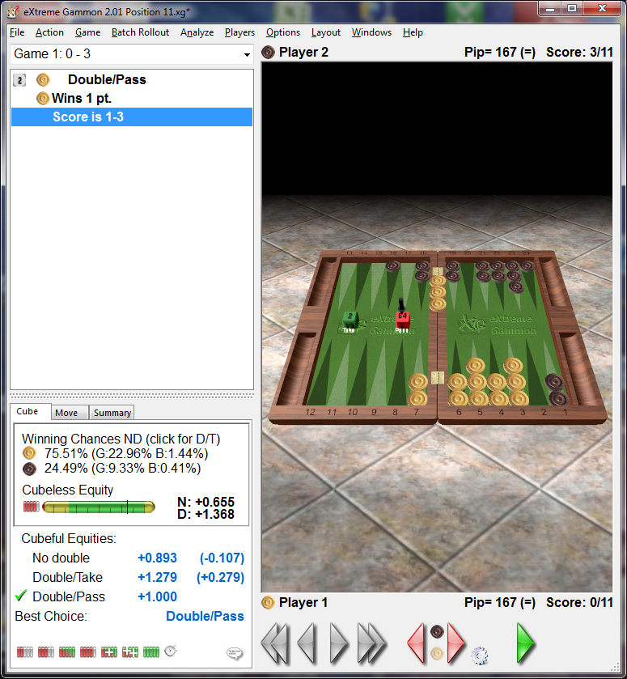
In play white never got to first base think cube at every roll
They never realised how strong their position was they did not cube
To get a result brown needs a couple of jokers
Of course we do not let the thought of jokers corrupt a good play
A perfect example of the power of the prime
Play this one out a few times
I played this out 15 times white won 11 times = 73% “say no more”

EXAMPLE I
WHITE TO CUBE

 | I
RACE | 5
RUNNERS
HOME POINTS MADE | 3
5 POINT MADE
ADVANCE ANCHOR
OPP ON BAR | 6
OPP BEHIND PRIME
THREAT & BUILDERS | 2
GAMMON POTENTIAL | 4
X OVERS
MISCELLANEOUS | 2
TOTAL | 70
XG | 76
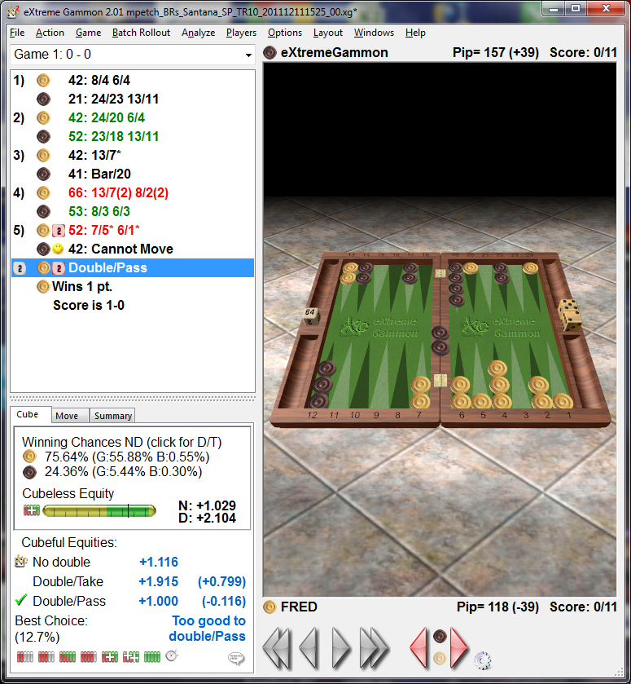
The two blots look scarey
This is one of those positions when any choice is good
Cube or no cube
I personally prefer no cube
XG has no flexibility in such positions has to obey his programmers

THE FOLLOWING IS PLAGURISED AND INCLUDED FOR INTEREST ONLY
RACING GAMES
Two choices
10-Percent Doubling Rule
A guideline for cube handling in pure race positions. If you add 10% to your pip count, you should double if the result is not more than two pips greater than the opponent's count, and you should redouble if the result is not more than one pip greater. Your opponent should accept the double if your count plus 10% is no more than two pips less than his count.
8-9-12 Doubling Rule
A guideline for cube handling in pure race positions. You should double if the opponent's pip count exceeds yours by 8% or more, and redouble if it exceeds yours by 9% or more. Your opponent should accept the double if his pip count exceeds yours by no more than 12%.
SHORT BEAR OFF
The checkers will ALMOST CERTAINLY bear off in the next four rolls

POSTION WINNING CHANCES CUBE ACTION
INITIAL DBL REDOUBLE
TWO ROLL 86% YES/DROP YES/DROP
THREE ROLL 79% YES/DROP YES/DROP
FOUR ROLL 73% YES/TAKE YES/TAKE
FIVE ROLL 68% YES/TAKE NO

TIMING
Timing is a means of determining how long you might hold a desirable position.
It is determined by counting the qualifying pip count and taking the difference.
The average roll is deemed to be eight.
But don't forget one can roll high or low.

HOLDING GAMES

A holding game is when a player tries to hold back an opponent by keeping a single anchor in his opponents home board, whilst creating and maintaining a desired position
They are many and varied. A strategy maybe is to let the dust settle to virtually a pure race. With or without contact then the long race rules apply.
Timing is vital
Holding the one or two point the correct cube is usually double/drop
Holding three or four point maybe win by hitting a blot or racing ,Use long race rules don’t forget to count crossovers to help your decision.
Holding five point you are in a good position as you control opponents outer board and theres a good chance of a hit
In the above two points are critical to your chances. If your opponent can make his bar point and clear his mid point your hitting chances go dramatically down.
If there is a possibility of your runners getting trapped its wise to leave the cube alone

CUBE ACTION IN BACK GAMES
ONE PLAYER HAS TWO ANCHORS MOST POTENTIAL ARE 1-3, 2-3, 2-4 ,3-4
ITS ALL ABOUT TIMING
BACK GAME COUNT GUIDE LINES
THE TIMING COUNT OF THE BACK GAME PLAYER NOT COUNTING THE HOLDING CHECKERS UNLESS THEY HAVE SPARES, MINUS THE PIP COUNT OF THE SPARES OF HIS OPPONENT
CUBE ACTION IN BACKGAMES
IF THE BACK GAME COUNT IS 43 OR LESS, FAVOURITE SHOULD DOUBLE
IF THE BACK GAME COUNT IS 41 OR LESS THE FAVOURITE SHOULD REDOUBLE
IF THE BACK GAME COUNT IS 35 OR MORE THE UNDERDOG SHOULD TAKE
IF THE BACK GAME COUNT IS LESS THAN 35 THE UNDERDOG SHOULD DROP
IF THE BACK GAME COUNT IS 20 OR LESS, THE FAVOURITE CAN CONSIDER PLAYING FOR GAMMON
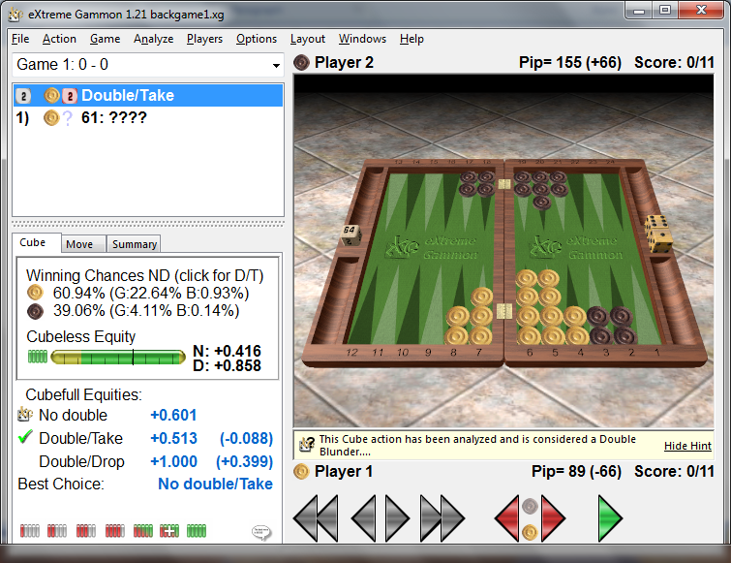

BLACKS TIMING COUNT (PIP COUNT) = 65 RUNNERS DONT COUNT UNLESS THERE SPARES
WHITES SPARES COUNT IS 29
65-29 = 34 WHICH IS LESS THAN 43 SO WHITE HAS A DOUBLE AND BLACK HAS A DROP
PERSONALLY I WOULD WAIT A ROLL THERE ARE NO DISASTER ROLLS
EASY TO COUNT START AT 6-6 THEN 5-5 THEN 4-4 THEN 3-3 THEN 2-2 THEN 1-1 ONLY ABOUT 20 CONFIRMS NO BAD ROLLS.
NOT IN AGREEMENT WITH XG BUT ITS NICE TO HAVE A LOGICAL OPINION
THE SYSTEM IS ONLY A GUIDE AFTERALL

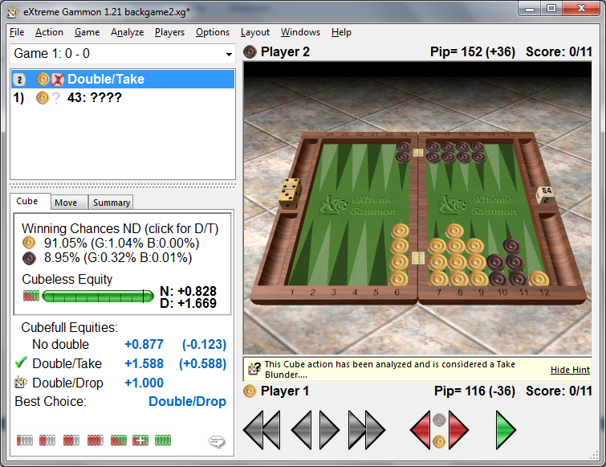
BLACK HAS A SPARE RUNNER TO CONSIDER . A 6 WILL BRING IT INTO PLAY.
A 30% CHANCE ITS COUNT THEREFOR IS 70% X 23=16 BEING THE BEST OUTCOME +50 =66
BLACKS COUNT 66 - WHITES SPARE COUNT 34 = 32
WHITE HAS A DOUBLE
BLACK IS LESS THAN 32 SO BIG DROP
STILL NO BAD ROLLS FOR WHITE
IN AGREEMENT WITH XG
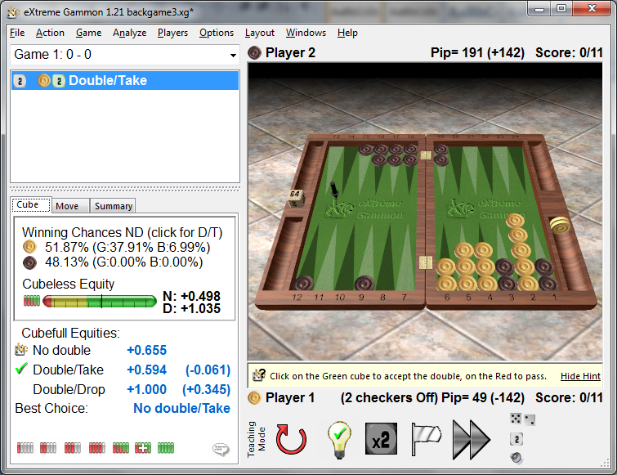
BLACK COUNT = 97
WHITE SPARES COUNT=15
TIMING COUNT = 97 – 15 = 82
NO DOUBLE /TAKE
THERES 8 BAD ROLLS FOR WHITE IE 22%
MAKES SENSE TO WAIT
WHEN YOU ARE ON THE VERGE OF CLEARING THE THIRD POINT IN FRONT OF THE HIGHEST ANCHOR
CONSIDER DOUBLING
counting bad Rolls is not as difficult as it seems
6-6 6-5 6-4 6-3 6-2 6-1 5-5 5-4 5-3 5-2 5-1 4-4 4-3 4-2 4-1 3-3 3-2 3-1 2-2 2-1 1-1
Don't forget back games are seldom won between matched players
Many opt for a back game far too early

Blitz games

an all-out attack on the opponent's runners in his home board

Blitz count

(attackers home board points} + (defenders men on the bar) – (defenders blocking points) –(attackers runners)
If you are doubled
if the Blitz count is one you are around your take point
if it is zero or less you should probably take
if it is two or more you should probably drop
if you are blitzing
if the blitz count is 2 could be correct to play on
when the count is 3 or more it is probably correct to play on
its a very small window all round the position can change dramatically
obviously not an exact science just a guide
you may wish to ignore all that
the points system seems to do a reasonable job
bearing in mind re runners escaped (no cube) and potential gammons

PRIME V PRIME
These types of games are many and varied
For that reason the following is just the basics
Timing is the be all and end all
Once again we have to give a value to our positions
Timing Count
Your Pip count not including your checkers blocked (runners)
Brown to play
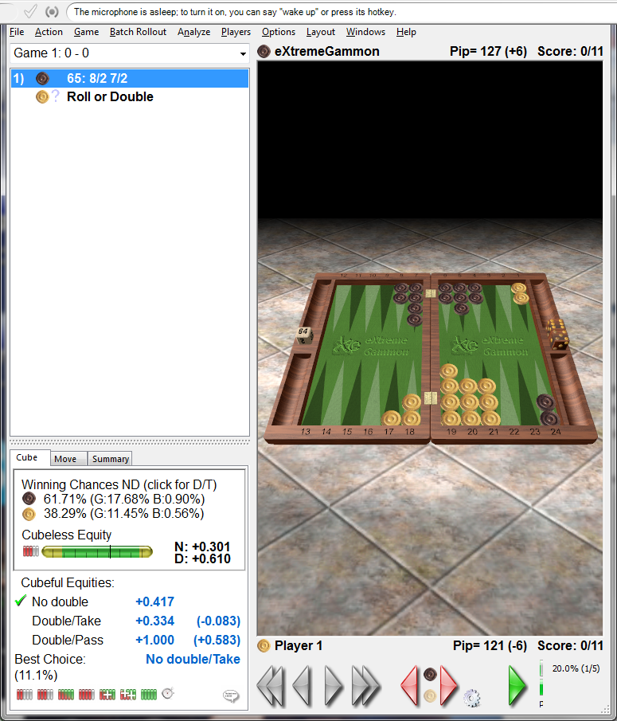
Brown's timing count 79
Whites timing count 73
Brown's timing advantage is therefore six
Cube Action
Timing advantage of 13 or more the favourite should double
Timing advantage of 15 or more the favourite should redouble
Timing disadvantage of 17 or less the trailer should take
Timing advantage of 24 or more the favourite can consider playing on for Gammon
Other features to consider
Prime strength
Each point in the prime is worth 8 points of timing
Add or subtract difference, 8 points for Brown
Do not count the nine point and beyond
Runners
Each runner is worth 10 points of timing
As each player have 2 runners trapped, no points
Brown has a timing advantage of 14 and should double
Builder count
A builder is a Spare chequer that is within six points of the front of the prime
A spare chequer anywhere behind a six prime is a builder
Two spare checkers on the same point count as one builder
A four prime should have 4 builders
A five prime should have 2 builders
A six prime should have one builder
Deduct 3 points for each missing builder and add three points for each extra builder
Fractured primes
Unless there is a solid four prime in the fracture don't bother
Advanced anchor count
Two point anchor is worth 2 points
Three point anchor is worth 5 points
Anchor escape count
Six escape is worth 15 points
Five escape is worth 25 points
Killed sixes
If you can arrange this it is worth five points
All these features will obviously not appear at the same time
Interestingly the additional features made no difference in the above example
Miscellaneous
Buzzwords
Volatility - a board position which supports the opportunity for big changes in equity in the next couple of Rolls
Equity -the value of the position
Vigorish -the small value received by an opponent when you pass the cube in that he has possession of the cube
Gammon vigorish - the value resulting from the opportunity of winning a Gammon
Effective Pip count (EPC)
A new one on me although it has been about for some time
I first became aware of additional stats on XG2
It is an aid to calculate the number of Rolls required to bear off
In bear off situations that are complex
A good article at
www.bkgm.com
Market
The opportunity to offer an acceptable double to your opponent which may not exist on the next roll
This is of course is a double edged sword it can come back to bite you on the bum
Don't bother with it until you're an expert
Woolsey's law
If you're not sure if it's a double then double
Ignore this law unless your Woolsey or at the least play as well as he
If you have got your head around all the above you will not need it

Match winning chances (MWC)
At any match score there are probabilities that you will win or lose the match
Of course these figures are only true between matched players
Once you have determined your MWC you then need to know
Your chances of winning the current game
If that is greater than the MWC then double
This is all getting a bit heady
I suggest you put it in the same bin as Woolsey's law
Just use common sense
Tips
Think cube every roll you can have a cube and drop on your second roll
Always be aware of the Pip count
Always be aware of your opponents blots especially in his home board
Dont play that obvious move quickly look for at least three candidates
Think hard when playing a double roll
Split your runners early if possible
When winning the race RACE
Don't play casually with your second dice use it wisely
When attacking a point optimise your attackers
To attack and cover the same point, square the spares within six points
To see how many do
There's a huge difference 4-9-16-25
Learn the opening moves and replies (I wish I could)
Many games are lost in the first couple of rolls by incorrect play
Learn the entry chances when on the bar (there higher than you think)
This will give you more confidence when hitting a blot
Don’t play with style because you think your opponent is a running donkey
Play the dice and cube not your opponent
Have a plan (even though it changes with every roll)
Dont try to consolidate a great position by offering a fly shot
Always be aware of your problems and look to solve them at the right moment
Play slow win fast
It does not necessarily mean you're cheating just that your old or sensible lol
I hope there's a nugget somewhere in this lot for you
There’s plenty more of course but I have seen many stumble on this one
When bearing off don’t stack to optimise doubles unless your next roll is probably going to be your last.
Just this very day this has been kicked into touch. You can convert a three roll position into a two roll position by stacking 4 on a point. You then need to roll a double for that point
All written with speech recognition, it's amazing now
HOMINID

I found this on the day i posted cube aid 04062015

White to cube

A
RACE | 4
RUNNERS | 2
HOME POINTS MADE | 4
5 POINT MADE | 2
ADVANCE ANCHOR
OPP ON BAR
OPP BEHIND PRIME | 8
THREAT & BUILDERS | 2
GAMMON POTENTIAL
MISCELLANEOUS | -12
TOTAL | 60
XG | 58
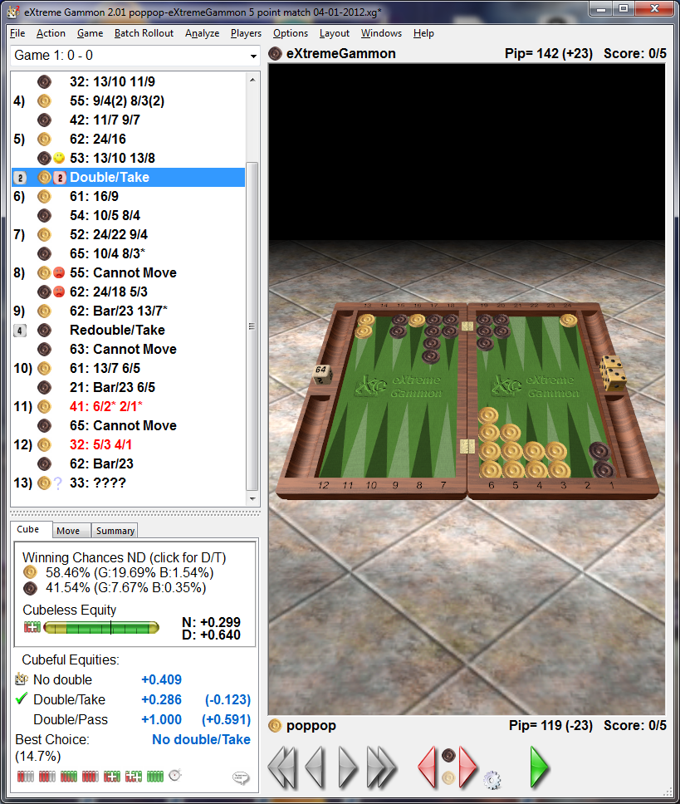
Miscellaneous Whites runner is still stuck behind a prime
System agrees with XG
Remember the rule of thumb if runners are not away take care

Brown to cube
B
RACE | 4
RUNNERS
HOME POINTS MADE | 2
5 POINT MADE
ADVANCE ANCHOR | 4
OPP ON BAR
OPP BEHIND PRIME | 8
THREAT & BUILDERS
GAMMON POTENTIAL | 4
MISCELLANEOUS
TOTAL | 62
XG | 66
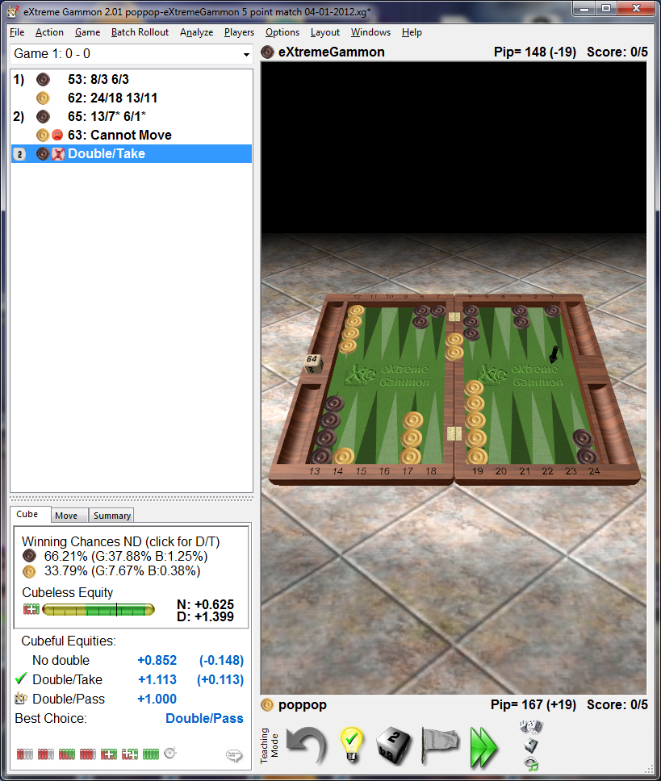
My points are adrift of XG they advocate D/T
But hold on the this system is not meant to handle blitz games
Interestingly the blitz system advocates D/T
So has XG got it wrong
I doubt it but you must remember that XG results are based by default on matched players
I ran this position five times white won 3
This is what I call a volatile position you never know the outcome
Personally I would not have doubled but I would probably take dependent on the match score
Beware the Gammon
It's a personality position
Some would say “but they may drop”
I would say thats psychology not BG are you good at that as well

White to cube
C
RACE | 1
RUNNERS
HOME POINTS MADE | 2
5 POINT MADE | 2
ADVANCE ANCHOR | 2
OPP ON BAR | 6
OPP BEHIND PRIME | 9
THREAT & BUILDERS
GAMMON POTENTIAL | 4
MISCELLANEOUS | -6
TOTAL | 70
XG | 64
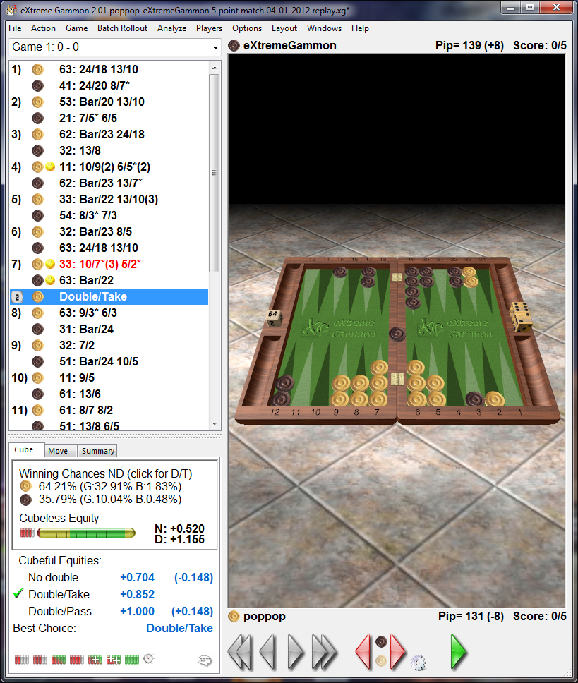
Note white needs 2 dice to escape hence - 6
I played this 5 times white won 4 black had 3 doubles in 4 rolls to win their game
The system appears top heavy but i believe the gammon chances don’t show in XG stats
I would drop this all day long

White to cube
D
RACE | 4
RUNNERS
HOME POINTS MADE | 2
5 POINT MADE | 2
ADVANCE ANCHOR
OPP ON BAR
OPP BEHIND PRIME | 12
THREAT & BUILDERS | 2
GAMMON POTENTIAL
MISCELLANEOUS
TOTAL +50 | 72
XG | 67
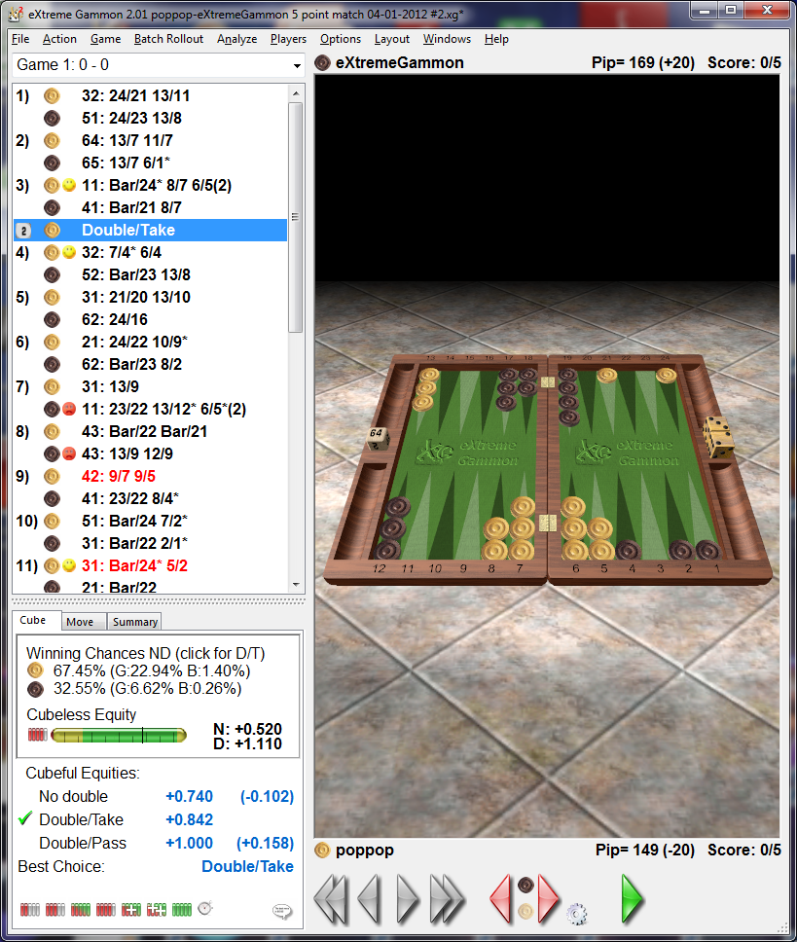
Certainly a big double not sure Ii would take over the table
going to be a battle
Looked to scary for the player

White to cube

E
RACE | 5
RUNNERS | 2
HOME POINTS MADE | 4
5 POINT MADE | 2
ADVANCE ANCHOR
OPP ON BAR | 6
OPP BEHIND PRIME
THREAT & BUILDERS | 2
GAMMON POTENTIAL
MISCELLANEOUS | -2
TOTAL | 70
XG | 58
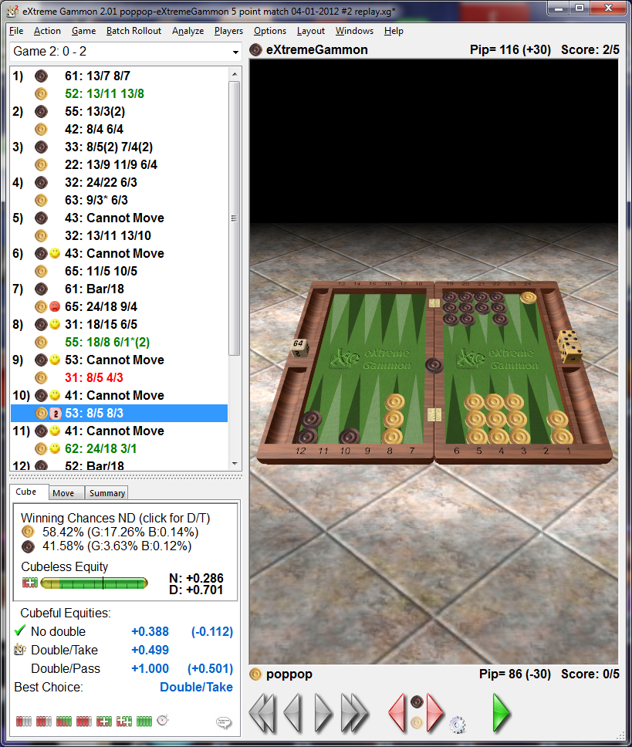
The system fails on the stats I cant see how 58% against 42% demands a double MWC PERHAPS
The miscellaneous deduction of 2 is runner behind prime and black has a strong hold on outfield
MWC does not explain it ah ha XG is wrong lol
The silver lining is the decision is correct its a double
Thats what we trying to achieve

Bown to cube
F
RACE | 1
RUNNERS | 5
HOME POINTS MADE | 3
5 POINT MADE | 2
ADVANCE ANCHOR
OPP ON BAR
OPP BEHIND PRIME | 8
THREAT & BUILDERS | 2
GAMMON POTENTIAL
MISCELLANEOUS
TOTAL | 71
XG | 78
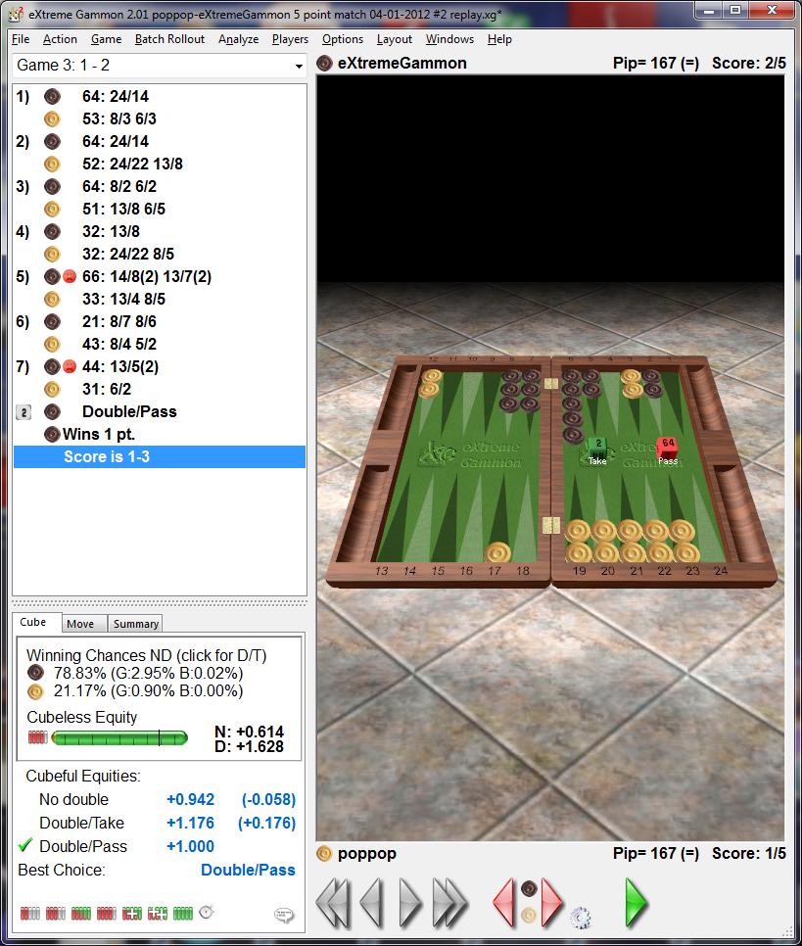
Ah we fail again but as i said the end decision is the same D/D

Brown to cube
G
RACE | 1
RUNNERS | 5
HOME POINTS MADE | 4
5 POINT MADE | 2
ADVANCE ANCHOR
OPP ON BAR
OPP BEHIND PRIME | 5
THREAT & BUILDERS | 6
GAMMON POTENTIAL
MISCELLANEOUS
TOTAL | 73
XG | 79
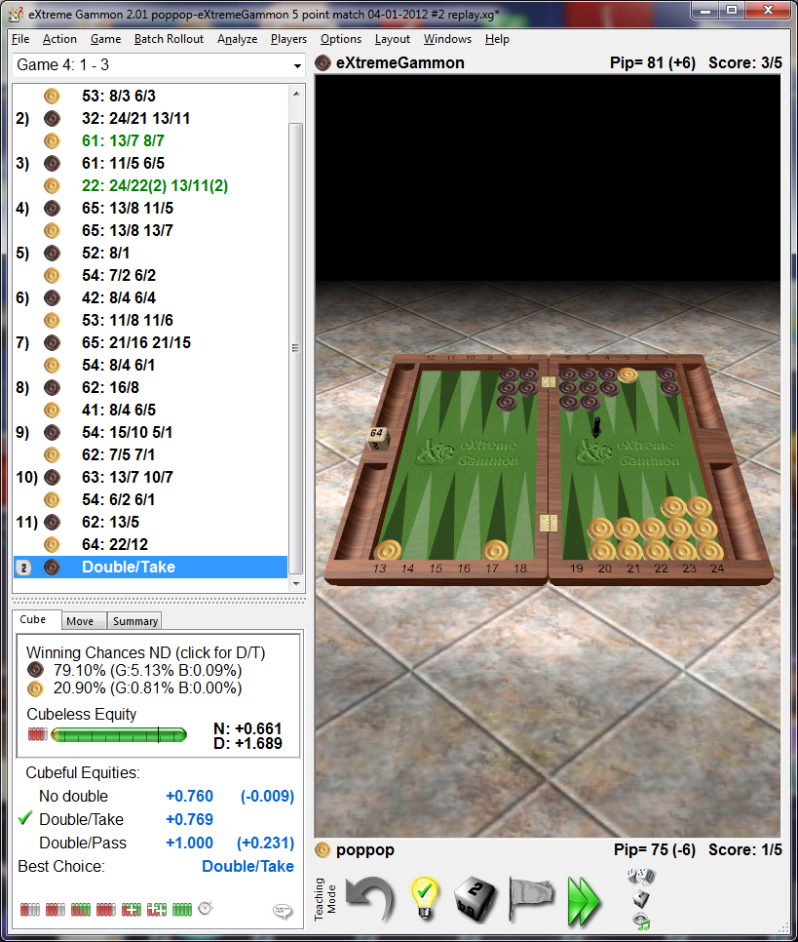

My stats are well adrift
I cant make head nor tail of this one , initially i thought MWC but it does not qualify
Brown has no bad rolls and has a 50% chance to hit and cover
He will probably hit lose if needs be, that runner must not escape
White will only likely lose one point Hang for a sheep as for a lamb he may get lucky
Its gotta be D/D in my book
Thers only one person on the planet who would take this
Mochy, i reckon he counts doubles rolled and theres some in his pot lol

The system handles early and middle games and more very well
Its all about primes you gotta use the right tackle at the right time and place
Same as fishing, im good at that to lol
There will be failures in the system it still has to grow
Let it grow with you
At the end of many hours it mostly produces the correct answer “turn that cube”
By missing cube oppurtunities games get complicated and humans begin to fail
Use the law
HOMINIDS LAW “ITS A CUBE TURN IT”
PS.
If you don’t find this helpfull then maybe you will get a laugh from it at my expense
Then my time will not have been wasted
Bye gone fishing

